# FYP Proposal Document

## **VOYAIGE**

## (Development)

**Group members:**

Hamza Rauf 21i-0604

Shamail Aamir Khan 21i-1772

Eman Furrukh 21i-1726

**Supervisor:**

Mr. Bilal Khalid Dar

**Co-Supervisor:**

Ms. Zoya Mahboob

Table of Contents

Project Overview 3

Problem Statement 3

Problem Solution 4

Goals 4

Existing Systems 4

Scope of Project 5

Stakeholders 5

Modules 5

Functional Requirements (FRs) 7

Non-Functional Requirements (NFRs) 8

1.1 Usability Requirements 8

1.2 Performance Requirements 8

1.3 Organizational Requirements 8

Process Flow 9

Tools 9

Technologies 10

Timeline and Work Division 10

Conclusion 11

References 12

# Project Overview

## Problem Statement

The sheer number of choices that must be made, from selecting locations to making reservations for housing, transportation, and activities, makes trip planning a complicated and involved process. Online users feel overwhelmed by the abundant options and information, leading to choice fatigue. The overwhelming choice and complexity of the travel purchasing process caused 91% of mobile customers to abandon their transactions. [1] Managing vacation plans, financial constraints, and personal preferences requires negotiation and compromise. The lack of integrated instruments for monitoring spending creates an extra challenge for effective budget management. There are numerous disjointed tools, which raises the possibility of mistakes and inefficiency.

Nowadays, many travelers plan, book, and coordinate their trip arrangements using apps and websites. According to reports more than 95% of travelers today use digital resources for their travel journeys. [2] To obtain useful information for planning their vacation, travelers depend more on user-generated reviews, influencer content, and recommendations from other travelers on social media platforms. These services provide inspiring travel options along with community-driven opinions and up-to-date information. By simplifying the planning process, efficient integration of various digital tools can enhance travel experiences for individuals and groups.

## Problem Solution

# In an era where planning a vacation may feel like navigating a maze of choices and unknowns, Voyaige stands out as a source of clarity for tourists traveling in Pakistan by addressing the numerous challenges associated with trip planning. It redefines personalization with the help of artificial intelligence (AI) and machine learning (ML), Voyaige ensures that users have a personalized daily schedule for their journey by using chatbots and recommendations based on user-filled forms. Voyaige provides consumers with comprehensive budget management tools that offer multiple recommendations. Although the user can generate a whole trip using AI, they also have the option to customize their trip, which includes booking all the transportation and lodging options.

# For users who may not have a specific destination, Voyaige offers pre-planned trips that allow customers to discover new possibilities and places. Voyaige offers tailored suggestions depending on user interests, prior travel experiences, and user reviews, as opposed to the general suggestions made on conventional travel websites. Websites offer user-generated content with insightful information that enhances the services and recommendations offered, enabling future travelers to make informed choices. Through Voyaige, users experience seamless travel planning and booking. Users no longer need to switch between numerous websites and apps.

# Goals

* Enhance Personalization
* Optimize Budget Management for Travel
* Reduce Trip Planning Time
* Deliver Reliable Recommendations for User

# Existing Systems

1. TripAdvisor

Pros:- Easy to Use, Vast options available to user

Cons:- Only has generic options for Pakistan

1. RoutePerfect

Pros:- Plans proper itineraries for users, Easy to Use, Smart Chatbot

Cons:- Has nothing to offer in terms of itineraries in Pakistan.

1. Expedia

Pros:- Easy to use, vast choices for user

Cons:- Chatbot provides links to users when assisting, but doesn’t help them plan out a trip.

# Scope of Project

The user will be welcomed onto the home page of our website where they’ll have three options in deciding how to plan their trip:

Firstly, they’ll have the option of chatting with our very own Chat-Bot Milo. They can enter any prompt, and Milo will help them plan an itinerary. They can type in “Plan a trip to the Northern Areas from Islamabad for 5 days”, that’ll get Milo to plan out a full itinerary from Day 1 to Day 5, planning where to go, what to visit, where you can stay, and the food they can enjoy there. For any customization the user wants to add, they can write/speak to Milo “Change Day 3 to fit into the budget of Rs10,000/-” and it'll update their itinerary.

Secondly, users can fill out a form answering basic traveling preferences like where their starting point is, where their destination will be, their budget, and the number of travelers they have. We will use AI to delve into the users’ choices and design the perfect itinerary based on what they’ve filled in the form. Users can still edit or update the itinerary to their satisfaction.

Thirdly, users can manually customize their entire trip. They can enter their starting point, destination point, duration point, and the number of travelers with them. They press the forward arrow button and will be presented with a page to help them fill in their itinerary along with the choice of hotels, transportation, and Airbnb for the entirety of the trip.

Besides the options of choosing how to plan their trip, users have the option of viewing tourist attractions with Panoramas (which provide a 360º view). They can also get recommended pre-planned trips based on their previous trips. They can book their transport (i.e., rent a car, book a bus, book a train), hotel, and Airbnb with the help of our website. Moreover, our website can recommend restaurants to visit based on users’ ratings and reviews. They can also take part in the challenges set by our website to earn points which can get them discounts for future trips!

# Stakeholders

Stakeholders include our Supervisor and Co-Supervisor i.e., Mr. Bilal Khalid Dar and Ms. Zoya Mahboob, respectively.

# Modules

We have several modules for our project:

1. Chatbot (Milo)

This module features an interactive chat interface powered by NLP and through Sentiment Analysis. Users can interact with Milo to help plan an itinerary and update it according to their satisfaction.

1. AI Trip Planning Form

This module allows users to fill in a small form which helps make a perfect itinerary for them based on the answers filled in the form i.e., your starting point, destination, budget, and number of travelers.

1. User Customized Trip Planning

This module allows you to customize your trip. You pick out the starting point, destination, duration, and number of travelers. After that, you pick out what you want to do on each day and pick out your transportation, hotel, or Airbnb to your liking directly from our website.

1. Tourist Attractions Panoramas

This module offers 360º panoramic views of various tourist attractions across the country. Users can interact with and navigate the images to explore numerous locations.

1. Recommendation Systems

This module provides personalized trip recommendations based on your previous trips. It also suggests restaurants to visit based on users’ reviews and ratings.

1. Booking Systems

This module allows users to book transportation (buses, cars, trains), hotels, or Airbnb’s. When customizing their trip, the User can edit each specific Day in the itinerary to add/update a booking for transport or accommodation.

1. Payment Options

This module provides users with multiple payment options, including online payment through Bank Transfer (Credit/Debit Cards) or EasyPaisa, and the ability to print an invoice for payment in cash or by cheque through their respective bank.

1. Challenges and Incentives

This module presents users with multiple challenges that they can take part in to earn points. Based on these points, they can redeem them to get vouchers which they can use to earn discounts on their next trip. Hence, this allows us to track user participation and manage the reward system.

# Functional Requirements (FRs)

Functional requirements:

1. ( Module ) Chatbot

* The user can communicate with Milo and customize the trip according to their satisfaction.
* The user can provide vocal commands, which speech-to-text recognition converts to text.
* The system allows users to make changes in the trip as they’re being generated.

1. ( Module ) AI Trip Planning Form

* The user is provided with a form to fill out to help AI understand the users’ preferences.
* The form takes information about the user required by AI to plan a perfect trip.

1. (Module ) User Customized Trip Planning

* Users can customize their trip by selecting what to do each day.
* The user can select their transportation and lodging from the list provided.
* While choosing this, the user is provided with the top recommendations for transport and lodging according to AI that best suits their budget.

1. ( Module ) Tourist Attractions Panoramas

* The system provides a better understanding to the users of the tourist attractions in the city.
* Users can interact with and navigate the images to explore various locations.
* The panorama helps users understand and navigate to explore the tourist attraction location.

1. ( Module ) Recommendation Systems

* The system provides the user with a pre-planned trip based on the previous trip explored or completed by the user.
* The user is also provided with other user reviews and ratings on the trip to help them understand their experience and decide to pursue this trip.
* The pre-planned trip provides accommodation and the best hotels, restaurants, and activities.
* The budget needed for the trip is also provided by the pre-planned trip; if the user is interested, they can pay now, and AI will make all the necessary reservations to make the journey enjoyable.

1. ( Module ) Booking Systems

* Users can book transportation and hotels directly from the website without navigating to another website.
* Booking can be done based on user choice.

1. ( Module) Payment Options

* The User has multiple payment options, including online payment, bank transfer (credit or debit cards), or EasyPaisa.
* The User will also be provided with the ability to print an invoice for payment in cash or by cheque through their respective bank.

1. (Module ) Challenges and Incentives

* The system provides challenges to complete to earn discounts on future trips.
* The system will keep track of the user's involvement and interactions in the challenges to award them points.
* Points that the user redeems are added when purchasing a trip package.

# Non-Functional Requirements (NFRs)

The Non-Functional Requirements for Voyaige will be the following:

### Usability Requirements

USE-1: The system shall be accessed on Google Chrome.

### Performance Requirements

PER-1: The system shall have a 5-second response time for user interactions.

### Organizational Requirements

ORG-1: The system shall be coded using Python and MERN

# Process Flow

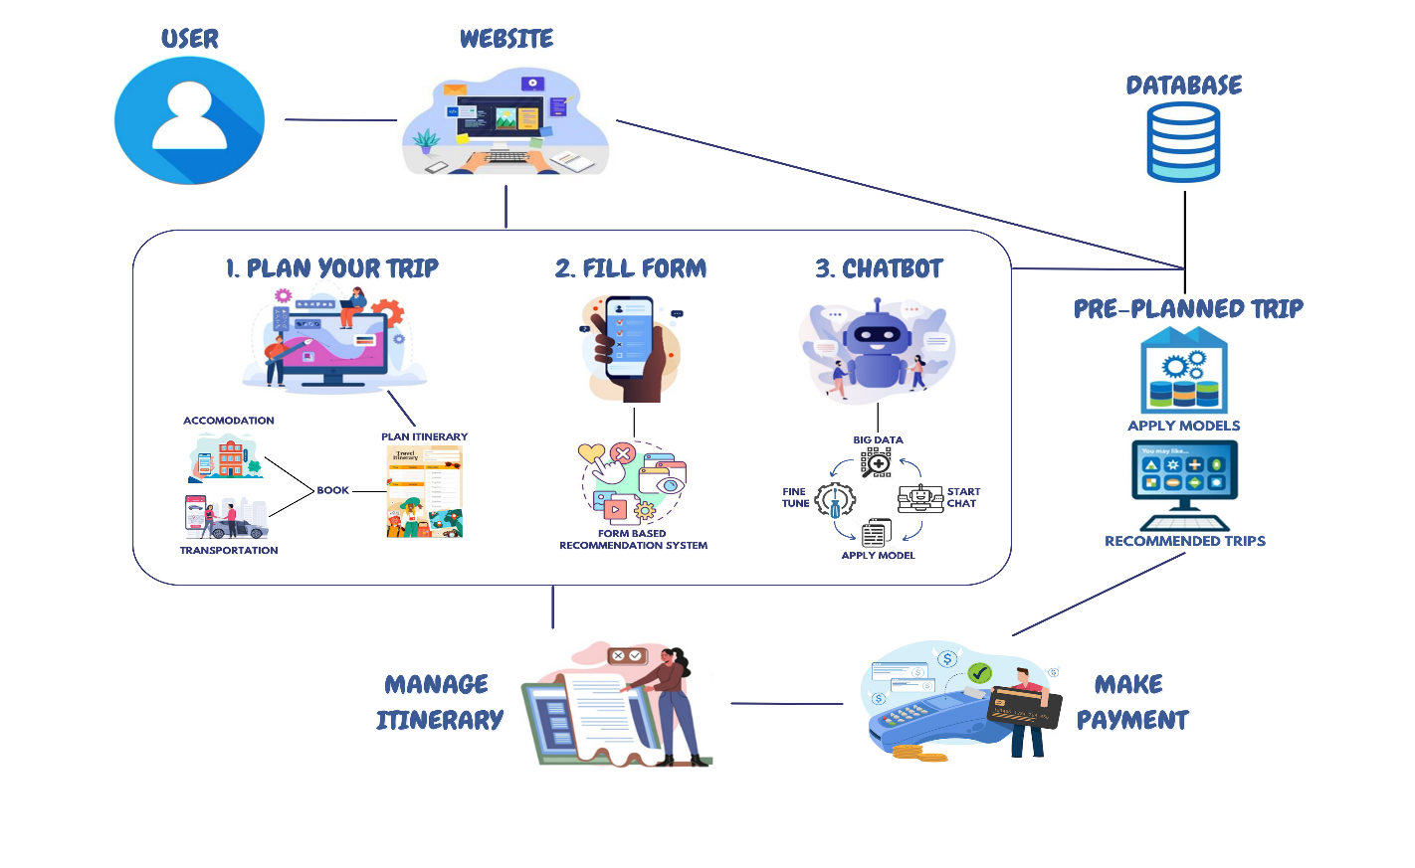The user will enter the home page and decide which method they would like to use to plan their trip i.e., Chat-Bot Milo, Form-Based Planning, or Custom Trip Planning. On the Home Page, they can view pre-planned trips, recommended cities, and restaurants. They can also view different tourist attractions through Panoramas. The users can edit, view, update, and delete any part of the itinerary.

**Figure 1: Process Flow Diagram for Voyaige**

# 

# Tools

* **Figma**
* **React**
* **Jupyter Notebook**
* **MongoDB**
* **VS Code**

# Technologies

|  |  |  |  |
| --- | --- | --- | --- |
| **Technologies** | **Hamza Rauf** | **Eman Furrukh** | **Shamail Aamir Khan** |
| **JavaScript** | 7 | 6 | 6 |
| **React** | 7 | 6 | 7 |
| **Express.js** | 6 | 5 | 6 |
| **Node.js** | 6 | 6 | 6 |
| **Python** | 5 | 7 | 7 |
| **Figma** | 6 | 7 | 7 |
| **MongoDB** | 5 | 7 | 7 |
| **GitHub** | 8 | 6 | 5 |
| **MS Word** | 9 | 9 | 8 |
| **MS PowerPoint** | 8 | 8 | 7 |

**Figure 2: Tools, Technologies and Members Expertise**

# Timeline and Work Division

Our project is divided into four iterations, with the first iteration being from August to October, the second from November to January, the third from February to April, and lastly, from May to July. The work has been distributed amongst the 3 members equally with each member leading one major feature and one minor feature with respect to the members expertise. Shamail will be leading the Chatbot and User Customization features. Hamza will be leading the Form-Based Recommendation System and the Challenges features. Lastly, Eman will be leading the Pre-planned Trip System along with the Tourist Attraction Panoramas.

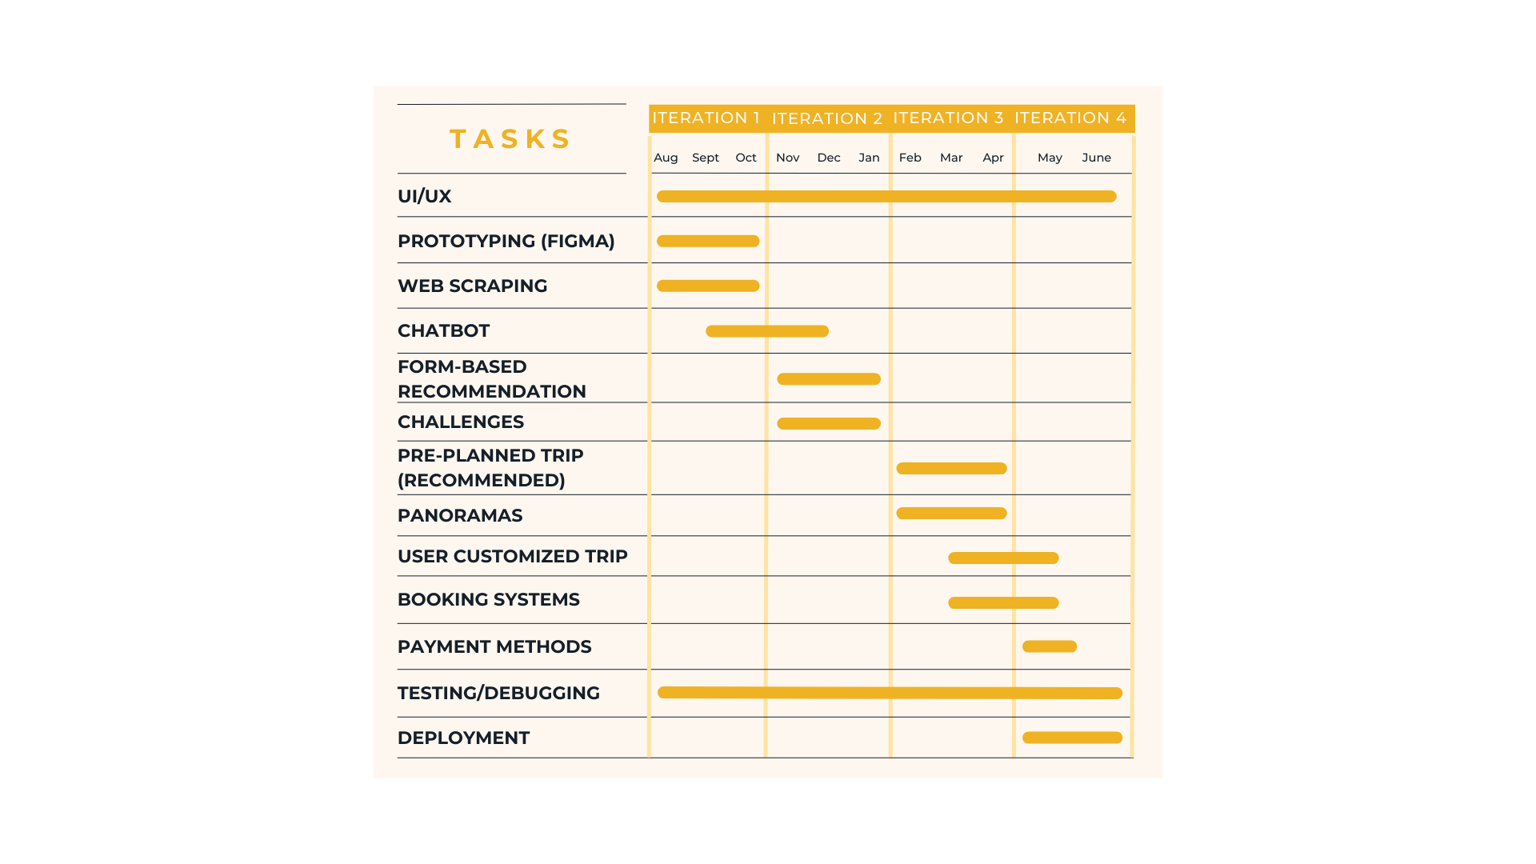

**Figure 3: Timeline & Work Division Gantt Chart**

# Conclusion

In conclusion, Voyaige is a breakthrough in the context of travel planning specifically for users from Pakistan. Given the developments in AI and machine learning, Voyaige helps optimize the difficult process of planning trips and presents users only with the best offers. The use of chatbots, form-based recommendations, pre-planned trips, and user-customizable trips allow for an effective feedback system allowing user satisfaction and efficient travel planning.

Moreover, Voyaige includes community-generated content and highlights the importance of positive social interactions. We are aspiring developers who are strongly committed to the successful development of Voyaige with the help of Mr. Bilal Khalid Dar. We are anticipating being able to help progress the travel industry and being a useful resource to travelers all over the world.

# References

[1] BCG (2014). "Travel Goes Mobile”, 2014 Article.

Link: <https://www.bcg.com/publications/2014/transportation-tourism-technology-digital-travel-goes-mobile>

[2] TravelPerk (2024). “60+ online travel booking statistics & trends", 2024 Article

Link: <https://www.travelperk.com/blog/online-travel-booking-statistics/>